**OBJECTIVE QUESTIONS**

1. **What is the total no. of tables present in the data?**

**Ans :** There are 2 sheets present in data each contains 1 table  
 Hence, there are 2 tables(Raw data & Country description).

1. **What is the total no. of attributes present in the data?**

**Ans :** Attributes simply means no. of rows.In sheet raw data 20 attributes are present.

1. **How many categorical columns are there in the data? [Search about categorical and continuous data, and try to answer this question]**
2. **Ans:** Categorical data simply means non numeric values so in raw data there are 15 categorical columns ( Restaurant ID, Restaurant Name ,CountryCode, date_key_opening, City, Address, Locality, Locality Verbose, Cuisines,Currency, Has Table Booking, Has Online Delivery, Is Delivering Now,Switch to Order Menu, Price Range) and 5 continuous columns (Longitude, Latitude, Votes, Average Cost for Two, Rating).
3. **The data consists of some inconsistent and missing values so ensure that the data used for further analysis is cleaned.**

**Ans:** The data consist of no duplicate values.I have formatted the table. And made a new sheet named **Cleaned Data**.

* The data provided has only the country code in the raw data so I have used lookup function to extract the country names from the country description sheet.
* Some rows of cuisine attribute are missing so I have assigned them the value according to their given location.

{ =INDEX('Raw Data'!$K$2:$K$9552,MODE.SNGL(IF(($D$2:$D$9552="United states of america")*('Raw Data'!$K$2:$K$9552<>""), MATCH('Raw Data'!$K$2:$K$9552,'Raw Data'!$K$2:$K$9552,0)))) }

* Some data have both latitude and longitude as 0 which is practically not possible so I have taken Average of values from that locality

[ =IF(I2=0,AVERAGEIF(E:E,"New Delhi",I:I),I2) LONGITUDE

=IF(J2=0,AVERAGEIF(E:E,"New Delhi",J:J),J2) LATITUDE ]  
if some city has no values to be taken for average, then I have taken average value of New Delhi.

=IF(AND(I2=0,J2=0),"Missing place","valid") -> to mark the inconsistent values.

* I have replaced ÛÁstanbul (doesn’t exist) to Istanbul.
* Through find and replace function , In the column Datekey_opening , I have replaced “_” with “-“ to make that column in proper date format. Then I made separate columns for day date and year of opening.

1. **Using the Lookup functions, fill up the countries in the original data using the country code.**

**Ans:** Made a column name **Country_Name** in **cleaned data sheet**

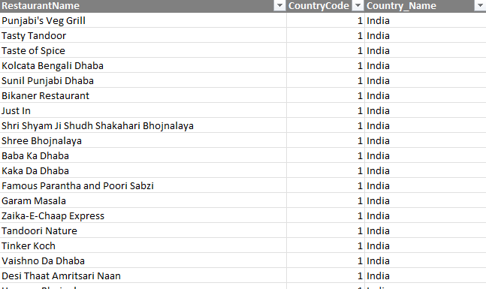

=VLOOKUP(C2,'country description'!$A$1:$B$16,2,0)

1. **Create a table to represent the number of restaurants opened in each country.**

**Ans:** Created the table in sheet named Pivot Table.

Values : Restaurant_Id

Rows: Country_name

**Observation:**

From the table we can see India has most number of restaurants whereas Canada has the least.

**Table :**

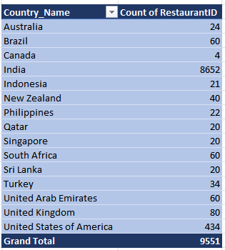

1. **Also, the management wants to look at the number of restaurants opened each year, so provide them with something here.**

**Ans:** Rows : Year

Values : Count of restaurant_ID

**Table & Visualization:**

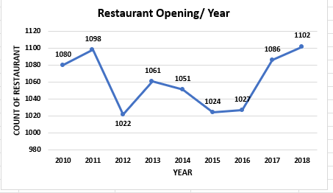

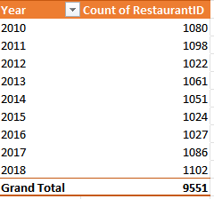

**Observation:**

From the table we can see In year 2018 most no. of restaurants was opened around the world followed by the year 2011

Least no. of restaurants was opened in the year 2012 ( We can see there is sudden decrease in numbers from the previous year).

Line chart is the perfect choice for comparing the trend of opening of Restaurant / Year.

1. **What is the total number of restaurants in India in the price range of 4?**

**Ans: :-** The number of restaurants in India that have price range 4 is **388**. This count I have calculated through COUNTIFS()

Formula :

=COUNTIFS(D:D,"India",T:T,4)

1. **What is the average number of voters for the restaurants in each country according to the data?**

**Ans :**

**Observation:**

From the bar chart we can see Indonesia has the highest number of average voters( the total number of restaurants is 21) whereas Brazil has least number of average voters ( Brazil has 60 restaurants).  
India has most number of restaurants but the average votes is 137.212 i.e approximately 137 voters which is quite less given the total number of restaurants present.  
  
**Visualization:**

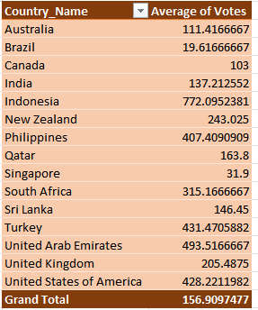

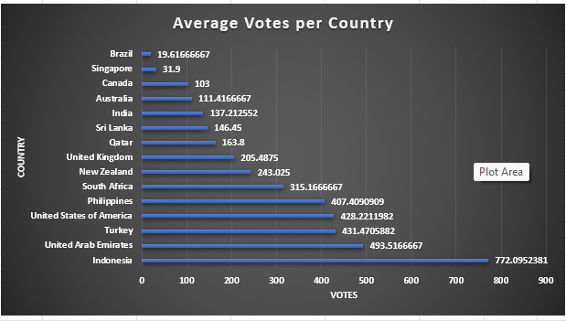

1. **Calculate the average rating for all the restaurants that have price_range < 4 and provide online delivery. Use only the “IF” function, Logical Operators, and Aggregation functions to solve this problem. [Note: Don’t use Conditional aggregation in this question.]**

**Ans:** 3.27381151

=AVERAGE(IF((T:T<4)*(Q:Q="YES"),W:W))

1. **Using Conditional formatting highlights the rows of restaurants that are located in the countries or cities that you’ve suggested to the management for opening new restaurants.**

**Ans :**

**Insights :**

I used conditional formatting and highlighted the countries on the basis of Number of restaurants, Country wise average rating. Screenshot is pasted below for the reference.So opening restaurant in **Canada, Singapore & Australia** is more feasible as there is less competition. By conditional formatting I have highlighted the attribute Country_name containing .

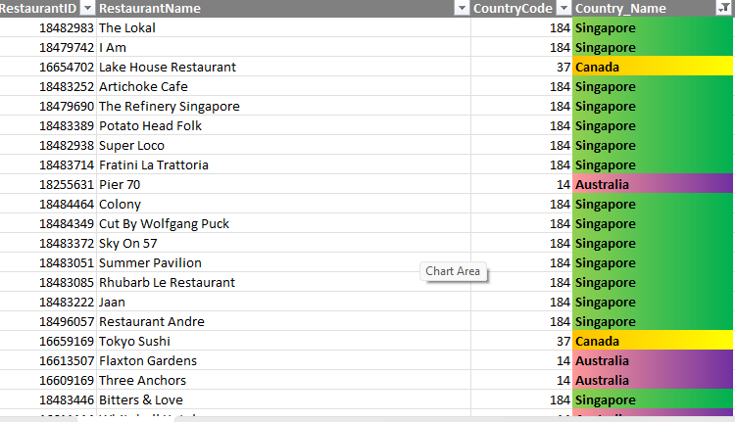

1. **Create a new customized price column that consists of the abbreviation/symbol of the currency along with the Average_cost_for_two value. [Use string operations to do this task]**

**Ans**: Created a new column named ‘Customized_Price’ in the Cleaned data Sheet and used formula

=MID(L2,FIND("(",$L2)+1,FIND(")",$L2)-FIND("(",$L2)-1) &" " & $S2

for this task.

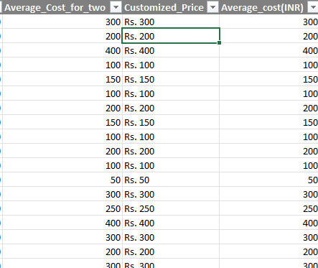

1. **How can you create an array formula in Excel or Google Sheets to count the number of restaurants listed that do not offer online delivery, are in the lowest price range, and have an average cost for two people less than or equal to 250 Indian Rupees?**

**Ans :** The number of restaurants which do not offers online delivery and have the lowest price range and have in average cost of two people less than or equals to 250 in the country India are **1694** by using the array function.

**Insights :**

To solve this question, I have converted the average cost for two which is in different currencies for different countries into rupees and then I have used the array formulagiven below :

=SUM(((N2:N9552="No")*(Q2:Q9552=1)*(U2:U9552<=250))*1)

Here , N -> online delivery , Q -> Price_range ,U -> Average cost in INR(Indian Rupees)

**Subjective Question:**

1. **Suggest a few countries where the team can open newer restaurants with lesser competition. Which visualization/technique will you use here to justify the suggestions?**

**Ans :**

**Visualization :**

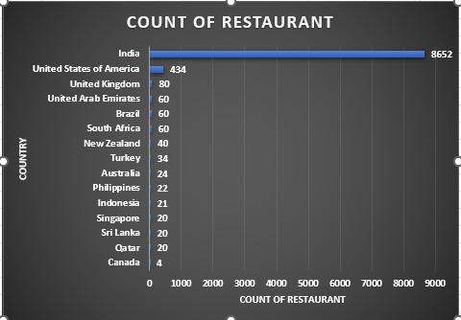

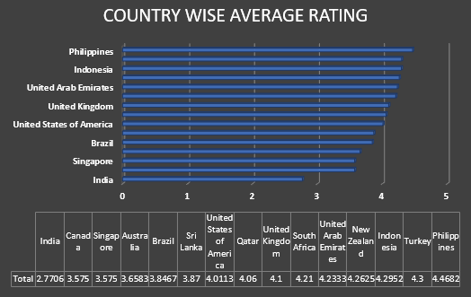

**Observation & Suggestion :**

* If we look into count of restaurant chart then Canada, Qatar, Singapore, Indonesia & Sri Lanka have least count of restaurants and In country wise average rating chart India, Canada, Singapore , Australia & Brazil stand out
* But we can’t consider India due to high count of restaurant as well as Qatar with higher average rating.
* Canada, Singapore, Brazil and Australia all meet the criteria of having moderately low restaurant counts and average ratings that are not exceptionally high, creating a potential market for a high-price range, premium restaurant.
* But ,Canada(4 restaurant & 3.575 rating) and Singapore(20 restaurant & 3.575 rating) & Australia(24 restaurant & 3.658 rating) stand out due to their very low number of restaurants and lower ratings, offering an opportunity to introduce a new and higher-quality dining experience with potentially less competition.
* Hence, My suggested countries are : **Canada, Singapore & Australia**

1. **Come up with the names of States and cities in the suggested countries suitable for opening restaurants.**

**Ans :**

|  |  |  |  |
| --- | --- | --- | --- |
| **Country & City** | **Count of RestaurantID** | **Average of Average_cost(INR)** | **Average of Rating** |
| **Australia** | **24** | **2023** | **3.658333333** |
| Armidale | 1 | 1680 | 3.5 |
| Balingup | 1 | 1680 | 3.2 |
| Beechworth | 1 | 1680 | 4.6 |
| Dicky Beach | 1 | 588 | 3.6 |
| East Ballina | 1 | 1680 | 4.1 |
| Flaxton | 1 | 2520 | 3.5 |
| Forrest | 1 | 1680 | 3.7 |
| Hepburn Springs | 2 | 1134 | 3.8 |
| Huskisson | 1 | 1680 | 4.1 |
| Inverloch | 1 | 588 | 3.7 |
| Lakes Entrance | 1 | 588 | 3.8 |
| Lorn | 1 | 1680 | 3.6 |
| Macedon | 1 | 1680 | 3.5 |
| Mayfield | 1 | 1680 | 2.9 |
| Middleton Beach | 1 | 2520 | 3.8 |
| Montville | 1 | 2520 | 2.4 |
| Palm Cove | 1 | 2520 | 4.4 |
| Paynesville | 1 | 10080 | 2.6 |
| Penola | 1 | 1680 | 3.4 |
| Phillip Island | 1 | 1680 | 3.7 |
| Tanunda | 1 | 2520 | 4.4 |
| Trentham East | 1 | 1680 | 4.1 |
| Victor Harbor | 1 | 1680 | 3.6 |
| **Canada** | **4** | **3045** | **3.575** |
| Chatham-Kent | 1 | 2100 | 3.7 |
| Consort | 1 | 2100 | 3 |
| Vineland Station | 1 | 5880 | 4.3 |
| Yorkton | 1 | 2100 | 3.3 |
| **Singapore** | **20** | **13083** | **3.575** |
| Singapore | 20 | 13083 | 3.575 |
| **Grand Total** | **48** | **6716.5** | **3.616666667** |

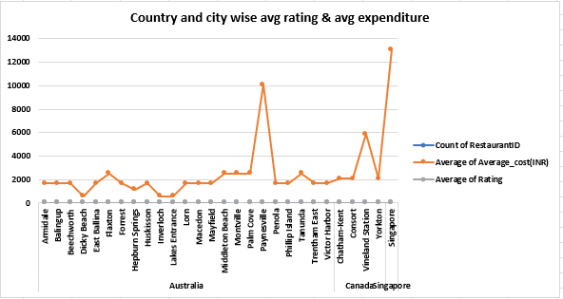

**Recommended Locations for New Restaurants:**

1. **Montville , Australia**
   * **Average Cost for Two :** 2520
   * **Average Rating :** 2.4
   * **Reason :** Despite Having only 1 restaurant the average rating is quite less i.e 2.4 which creates an opportunity for new restaurant to capture the market easily by upgrading the standard of restaurant.
2. **Mayfield , Australia**
   * **Average Cost for Two**: Rs 1680
   * **Average Rating**: 2.9
   * **Reason**: It has only 1 restaurant with poor average rating of 2.9 hence we can capture the market by improving the taste of food or by making some fusion dishes.
3. **Balingup , Australia**
   * **Average Cost for Two**: 1680
   * **Average Rating**: 3.2
   * **Reason** : It has only one restaurant with a low moderate rating of 3.2, This creates an opportunity for a new restaurant to capture the market by offering a superior dining experience.
4. **Consort** ,**Canada**
   * **Average cost for Two:** 2100
   * **Average Rating :** 3
   * **Reason :** It has only one restaurant, making it an ideal location with minimal competition. The average rating of 3 suggests room for improvement, offering an opportunity to introduce new dining experiences.
5. **Singapore**
   * **Average Cost for Two :** 13083
   * **Average Rating :** 3.575
   * **Reason :** It has 20 restaurants in spite of that the average rating is less hence giving the room for new restaurants to grow. But we should upgrade the quality of restaurant in comparison with the existing ones.
6. **According to the countries you suggested, what is the current quality regarding ratings for restaurants that are open there?**

**Ans : Approach:**

The Countries which I have selected for opening the new restaurants has current quality of average rating is less than 4, also have less number of restaurants already present there.

**Visualization :**

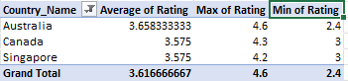

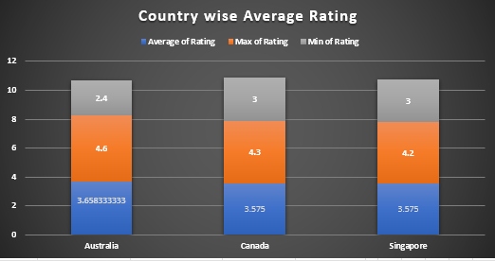

**Observation :**

* The average rating of these countries is between 3.5 to 4.

**Canada** and **Singapore’s** average rating are same i.e 3.575

The rating of **Australia** is more i.e 3.658

**Suggestions for Improvement**

* Above Average Ratings: All highlighted countries exhibit above-average ratings, indicating successful restaurant models that resonate with customers.
* Learn and Implement:
* Analyze the successful practices and strategies employed by top-rated restaurants in these regions.
* Focus on aspects such as menu offerings, customer service, ambiance, and marketing strategies to attain success.

1. **Also, what is the current expenditure on food in the suggested countries, so we can keep our financial expenditure in control?**

**Ans : Approach:**

To answer the above question we have to check average cost of 2 people in suggested countries and the currency would be in same manner, so for that I converted all currencies into Indian Rupees so that we can compare easily and fairly.

1. Average cost in Canada = Rs. 3045
2. Average cost in Singapore = Rs. 2023
3. Average cost in Australia = Rs. 13083

**Visualization :**

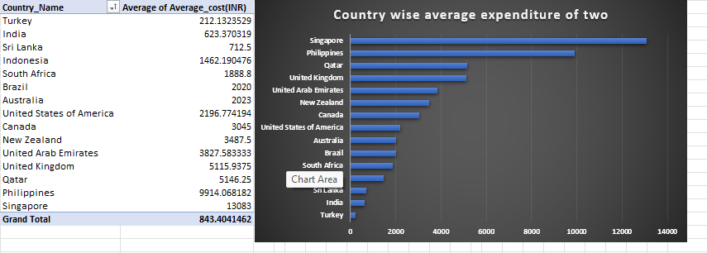

Below is the average expenditure of selected country:

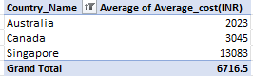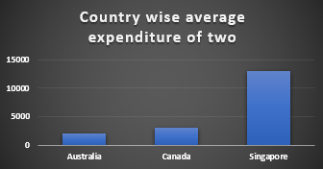

**Insights:**

1. Canada having only 4 restaurants with an average cost of Rs.3045, indicates a good opportunity for growth because of low competition and an economical pricing.
2. Singapore is having the highest average cost in the above suggested countries.
3. Australia has the lowest average cost among the suggested countries. This may indicate that people are more budget-conscious.

**Recommendation:**

1. Canada shows a significant opportunity for new restaurants because of the less competitive market along with economical expenditure. Expanding here will give us a strong opportunity to capture a good customer base.
2. Singapore, has highest average expenditure. That means People in that country are used to paying more for meals, meaning premium pricing strategies could work well. We can introduce premium menus, exclusive experiences, or higher-end ambiance and still stay competitive. As mentioned before, offering cuisine specific restaurant with a high focus on quality of food and a good dining experience will gain us a good advantage to capture the market despite the high competition.
3. In Australia, Customers are cost-conscious, they likely prefer budget-friendly options. We should Focus on quick service, combo offers, or popular affordable items .Many restaurants might compete on price we ,can stand out by offering better taste, hygiene, or service even at similar prices but that can lead to less Profit margin so we need to properly manage the cost while opening restaurant here .Also we need to take care that we can’t compromise quality while trying to make the food cheap.

1. **Come up with the names of restaurants from the recommended states that are our biggest competitors and also those that are rated in the lower brackets, i.e. 1-2 or 2-3.**

**Ans : Approach :**

Lower bracket : Rating <=3

Competitor : Rating >= 4 (Highly Rated )

|  |  |
| --- | --- |
| Rating | (All) |
|  |  |
| **City & Restaurant** | **Sum of Rating** |
| **Balingup** | **3.2** |
| Taste of Balingup | 3.2 |
| **Consort** | **3** |
| Consort Restaurant | 3 |
| **Mayfield** | **2.9** |
| Star Buffet | 2.9 |
| **Montville** | **2.4** |
| Poets Cafe | 2.4 |
| **Singapore** | **71.5** |
| Al'frank Cookies | 4.2 |
| Artichoke Cafe | 3.2 |
| Artistry | 3.8 |
| Bitters & Love | 3.9 |
| Boufe Boutique Cafe | 3.2 |
| Chye Seng Huat Hardware | 3.7 |
| Colony | 3.8 |
| Cut By Wolfgang Puck | 4 |
| Fratini La Trattoria | 4.1 |
| I Am | 3.2 |
| Jaan | 3.8 |
| Makansutra Gluttons Bay | 3 |
| Potato Head Folk | 3.1 |
| Restaurant Andre | 3.8 |
| Rhubarb Le Restaurant | 3.9 |
| Sky On 57 | 3.4 |
| Summer Pavilion | 3.9 |
| Super Loco | 3.2 |
| The Lokal | 3.1 |
| The Refinery Singapore | 3.2 |
| **Grand Total** | **83** |

In **Balingup (3.2) , Consort(3) , Mayfield(2.9) & Montville (2.4)** only 1 restaurant is present as shown above and all these restaurants have Rating < 4 So, in these cities the biggest competitor are the restaurants **Taste of Balingup , Consort Restaurant , Star Buffet , Poets Café respectively** in spite of their lower rating

In Singapore following are the biggest competitor :

|  |  |
| --- | --- |
| **City & Restaurant** | **Sum of Rating** |
| **Singapore** | **12.3** |
| Al'frank Cookies | 4.2 |
| Cut By Wolfgang Puck | 4 |
| Fratini La Trattoria | 4.1 |
|  |  |

Following is the list of low bracket restaurants :

|  |  |
| --- | --- |
| Rating | (Multiple Items) |
|  |  |
| **City & Restaurant** | **Sum of Rating** |
| **Consort** | **3** |
| Consort Restaurant | 3 |
| **Mayfield** | **2.9** |
| Star Buffet | 2.9 |
| **Montville** | **2.4** |
| Poets Cafe | 2.4 |
| **Singapore** | **3** |
| Makansutra Gluttons Bay | 3 |
| **Grand Total** | **11.3** |

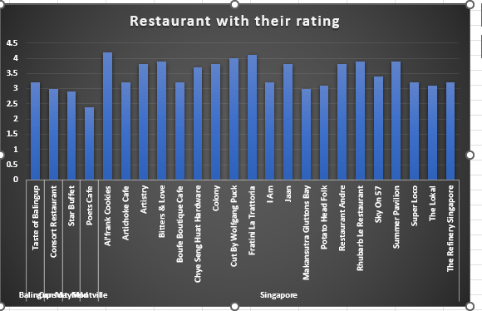

1. **Which cuisines should we focus on in the newer restaurants to get better feedback? Does the choice of cuisines affect the restaurant ratings?**

**Ans :** I feel that ratings depend on many factors not only on cuisines   
it also depends on cleanliness, ambience, variety of cuisines , Service provided by the restaurant ( like their attitude towards customers ,etc), Location . these are some of the main features that I feel affects Ratings. In conclusion cuisines does affect ratings but there are other factors as well.

|  |  |
| --- | --- |
| Rating | (All) |
|  |  |
| **Row Labels** | **Sum of Rating** |
| **Balingup** | **3.2** |
| **Taste of Balingup** | **3.2** |
| Modern Australian | 3.2 |
| **Consort** | **3** |
| **Consort Restaurant** | **3** |
| Chinese, Canadian | 3 |
| **Mayfield** | **2.9** |
| **Star Buffet** | **2.9** |
| Asian | 2.9 |
| **Montville** | **2.4** |
| **Poets Cafe** | **2.4** |
| Coffee and Tea, Modern Australian | 2.4 |
| **Singapore** | **71.5** |
| **Al'frank Cookies** | **4.2** |
| Bakery | 4.2 |
| **Artichoke Cafe** | **3.2** |
| Cafe, Spanish, Turkish, Greek | 3.2 |
| **Artistry** | **3.8** |
| American, Bakery, European, Burger, Fusion | 3.8 |
| **Bitters & Love** | **3.9** |
| Finger Food | 3.9 |
| **Boufe Boutique Cafe** | **3.2** |
| Italian, French, Bakery, Cafe | 3.2 |
| **Chye Seng Huat Hardware** | **3.7** |
| Cafe | 3.7 |
| **Colony** | **3.8** |
| Asian, Continental, Seafood | 3.8 |
| **Cut By Wolfgang Puck** | **4** |
| American, Steak | 4 |
| **Fratini La Trattoria** | **4.1** |
| Italian | 4.1 |
| **I Am** | **3.2** |
| Western, Fusion, Fast Food | 3.2 |
| **Jaan** | **3.8** |
| French | 3.8 |
| **Makansutra Gluttons Bay** | **3** |
| Singaporean, Chinese, Seafood, Malay, Indian | 3 |
| **Potato Head Folk** | **3.1** |
| American | 3.1 |
| **Restaurant Andre** | **3.8** |
| French, Mediterranean, European | 3.8 |
| **Rhubarb Le Restaurant** | **3.9** |
| French | 3.9 |
| **Sky On 57** | **3.4** |
| Chinese, Continental, Singaporean | 3.4 |
| **Summer Pavilion** | **3.9** |
| Chinese, Seafood, Cantonese, Dim Sum | 3.9 |
| **Super Loco** | **3.2** |
| American, Mexican | 3.2 |
| **The Lokal** | **3.1** |
| Singaporean, Australian, German | 3.1 |
| **The Refinery Singapore** | **3.2** |
| American, Japanese, Singaporean | 3.2 |
| **Grand Total** | **83** |

**Approach:**

Yes, Cuisines will definitely affect the restaurants ratings, because each city has different cuisines liked in different areas, for this I created the Pivot table. Through pivot table we can understand easily the restaurants, cuisines and their rating as well.

**Insights :**

* Restaurants in Balingup, Consort , Mayfield and Montville serving

Modern Australian , Chinese & Canadian , Asian , Coffee& Tea, Modern Australian respectively give average rating

* While in Singapore restaurant serving bakery, American , steak & Italian have quite good rating so we can these dishes are popular in Singapore.

**Recommendation:**

* In Mayfield & consort coffee, tea, Modern Australian Chinese & Canadian cuisine are rated low. Focus in providing authentic cuisine with a unique dining experience will help capture the market.
* Similarly, Montville is rating average in all global cuisines. Dining experience and authentic food should be given more importance.
* We can also include cuisines which are trending worldwide to have variety in restaurant.
* We should also consider taking regional favourites in menu which will help in getting better customer feedback . or we can also opt for fusion of regional and trending cuisines which will admire customers

1. **According to our current data, should we go for online delivery and table booking? Does that affect the customer’s ratings?**

**Ans :**

**Approach :**

Adding online delivery and table booking will help in increasing the ratings . these features show flexibility, convenience, and modern service. So, incorporating it in new restaurants will surely increase the chance of more customers.

We can use averageif function to calculate the average rating for both cases(i.e yes & no) [=AVERAGEIF(N:N,"yes",U:U) ]

Has_online _delivery : Yes - 3.288004896

No - 2.754309859

Has_table_booking : Yes - 3.482556131

No - 2.809686644

Thus, adding both the feature will increase the average rating.

**Insights:**

1. Restaurants with online delivery have a higher average rating compared to others. This suggests that offering online delivery services can enhance customer satisfaction and overall ratings.
2. Similarly, restaurants that provide table booking options have a higher average rating compared to those that don’t. This indicates that customers value the convenience of reserving a table.

**Recommendation:**

1. It is evident in the charts that restaurants that provide online deliveries and table bookings receive a higher rating than those that don’t.

**Visualization :**

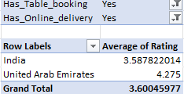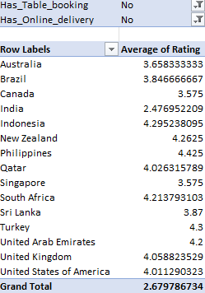

Also, I pasted the different of pie charts which are showing separately the percentage of average ratings for the restaurants has online deliveries and the restaurants which have table bookings there are slightly a difference between them

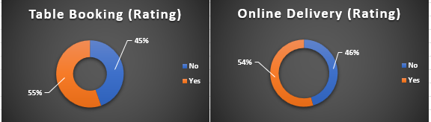

1. **Should the team keep the rate of cuisines higher? Will that affect the feedback? According to our data are the rates of cuisines and ratings, correlated?**

**Ans : Approach :**

Increasing the cuisine rate depends on country as for an instance Indonesia has high average expenditure as compared to other countries so increasing cuisine rate might less affect the feedback if we keep up with the quality food and hygiene. But increasing cuisine rate in Australia will definitely affect the feedback as in that country the average expenditure is less.

But to calculate that in general We can use correl function to check for the dependencies between cuisines and rating [ =CORREL(U:U,V:V) ]

0.309430106 , As this This value is very close to 0, which means There is almost no linear correlation between rating and average cost of two. Thus ,Increasing or decreasing the price doesn’t affect how customers rate the restaurant.

**Insights:**

1. Here in below pivot table, it shows the correlation between average cost of two in Indian rupees and average rating.
2. Here we get the value 0.309430106 by using correlation formula between Average cost(INR) & rating which not seen to very much good.

**Recommendation:**

1. As we can see, there is no correlation between ratings and average cost of the countries.
2. High ratings can be found at various price points this indicates that there are other factors that play a significant role in determining the ratings and customer satisfaction.

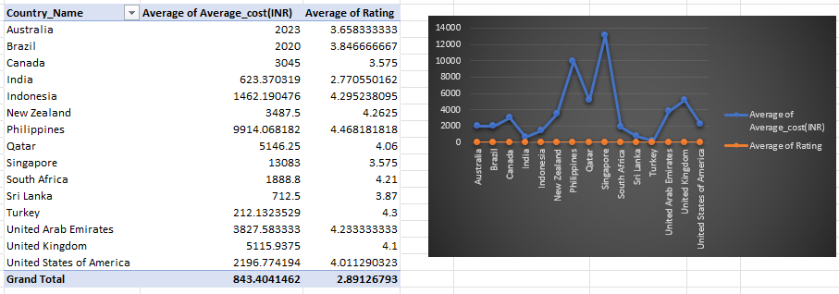

1. **What is the distribution of the number of restaurants of different price ranges in all the countries?**

**Ans :** **Approach:**

Different countries have different number of restaurants within the different price range. Whereas India have the maximum number of the of the restaurants among all price ranges. States such as the United States, United Kingdom, and South Africa have a more balanced distribution across the different price ranges but with significantly lower totals compared to India. Countries like Canada, Singapore & Australia have minimum number of restaurants

**Visualization & pivot table :**

|  |  |  |  |  |  |
| --- | --- | --- | --- | --- | --- |
| **Count of RestaurantID** | **Price_Range** |  |  |  |  |
| **Country_Name** | **1** | **2** | **3** | **4** | **Grand Total** |
| Australia | 4 | 14 | 5 | 1 | 24 |
| Brazil | 2 | 7 | 16 | 35 | 60 |
| Canada |  | 3 |  | 1 | 4 |
| India | 4295 | 2858 | 1111 | 388 | 8652 |
| Indonesia |  | 1 | 20 |  | 21 |
| New Zealand | 3 | 4 | 17 | 16 | 40 |
| Philippines |  | 1 | 12 | 9 | 22 |
| Qatar |  | 1 | 5 | 14 | 20 |
| Singapore |  | 1 | 5 | 14 | 20 |
| South Africa |  | 4 | 17 | 39 | 60 |
| Sri Lanka |  | 6 | 11 | 3 | 20 |
| Turkey |  | 11 | 18 | 5 | 34 |
| United Arab Emirates |  | 9 | 29 | 22 | 60 |
| United Kingdom | 4 | 28 | 32 | 16 | 80 |
| United States of America | 136 | 165 | 110 | 23 | 434 |
| **Grand Total** | **4444** | **3113** | **1408** | **586** | **9551** |

**Insights:**

1. As evident in the Chart, more number of the restaurants i.e. more than 4000 fall under the price range of 1. This indicates that most restaurants offer affordable dining experience.
2. And only few restaurants are in the price range of 4.

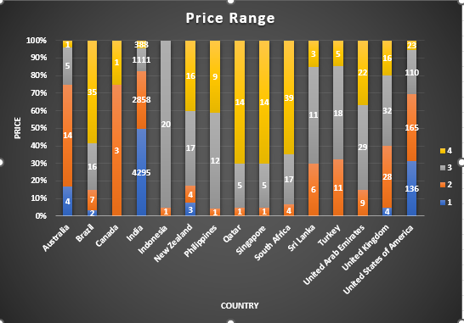

**Observation :**

The distribution shows which countries have high concentration of premium restaurants or budget-friendly options .So, we can open restaurant accordingly for an instance Countries with mostly mid or low-price restaurants may have market gaps in premium experiences, ideal for a high-end launch . Alternatively, countries with few low cost restaurants indicate a great opportunity to serve budget conscious consumers.

1. **Explain your approach in brief for suggesting countries/cities in order to open new restaurants, if the objective and subjective questions would have not been given to assist you. [you have to give bullet pointers in order to answer this question]**

**Ans :**  **Country and City Selection Strategy**:

* **Low Competition:** Select countries and cities based on a strategic analysis of restaurant density. The aim is to enter markets with fewer existing restaurants to minimize direct competition and increase the chances of establishing a strong market presence. The columns Country, City, Latitude and Longitude could be used for making a Map Chart which could give us a clear view of the restaurant density within a city and we could have used that data for suggesting the location for opening of the new restaurant. This would have been the most interesting part of the analysis.
* **Ratings :** After listing out countries, The first thing that comes to my mind is the rating. So, I would surely consider countries based on rating.
* **Quality of Food:** Focus on cities where the average cost for two is high. This suggests a higher spending capacity among customers, which provides an opportunity to introduce affordable yet high-quality food options. We can also check the cuisine trends in these countries to gain knowledge about what cuisines we should include in new restaurant.
* **Way of Delivery :** Focus on those countries which have online delivery as well as table bookings because it helps in increasing the sales of the restaurants.